Lab 4

Exercise 1.1 Neo4j money Laundering dataset analysis
CALL
apoc.cypher.runFile("https://gist.githubusercontent.com/apogiatzis/7e53f828f0566980b935b314d575226d/raw/682a030f9c24a46e67e6481ea66c484bca54c5a4/lab3_ex_import.cypher")

CALL db.schema.visualization();

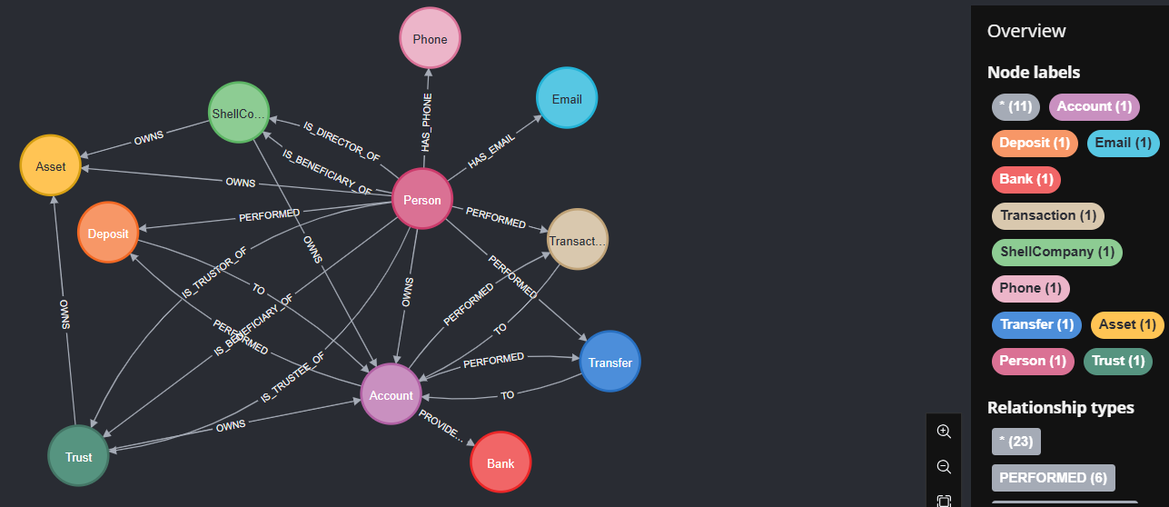
MATCH (n)
RETURN head(labels(n)) as type, count(*) as count

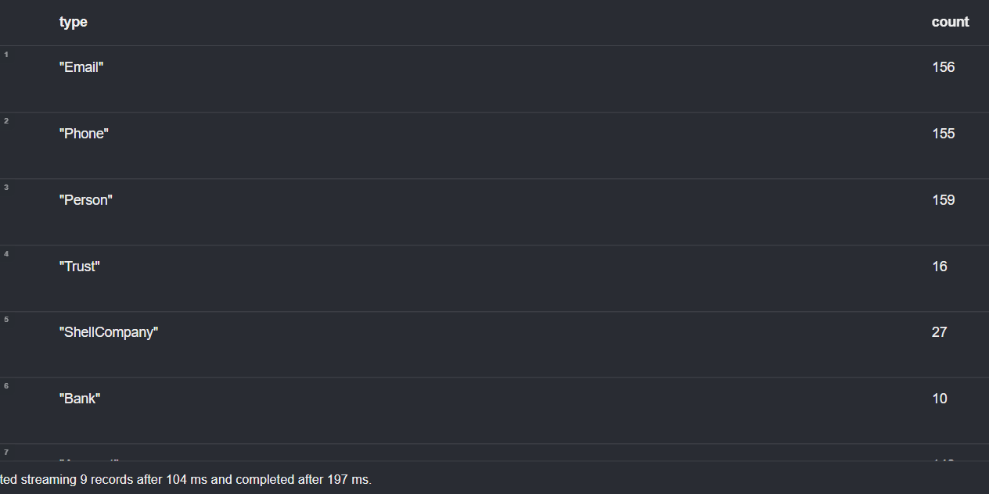
MATCH (p:Account)
WITH apoc.node.degree(p,"<") AS inDegree, apoc.node.degree(p,">") AS
outDegree
RETURN inDegree, outDegree
ORDER BY inDegree DESC;

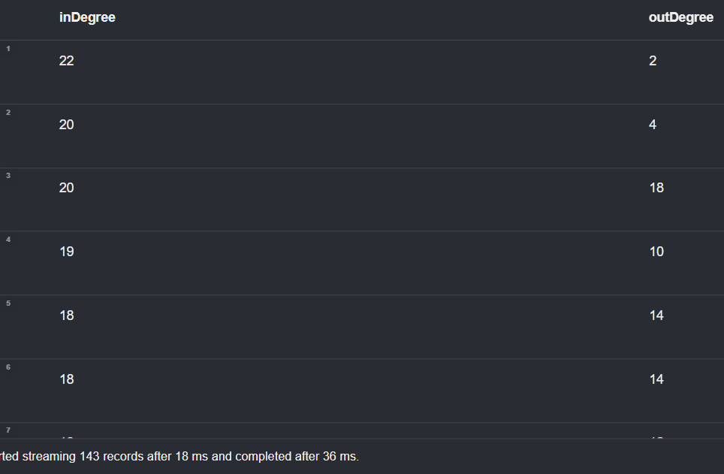
MATCH (p:Account)
RETURN apoc.node.degree(p,"<TO") AS inDegree
ORDER BY inDegree DESC;

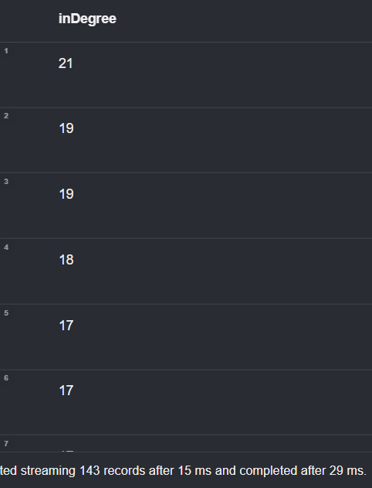
MATCH (p:Account)
RETURN apoc.node.degree(p,"<TO") AS inDegree, p.obj_id
ORDER BY inDegree DESC;

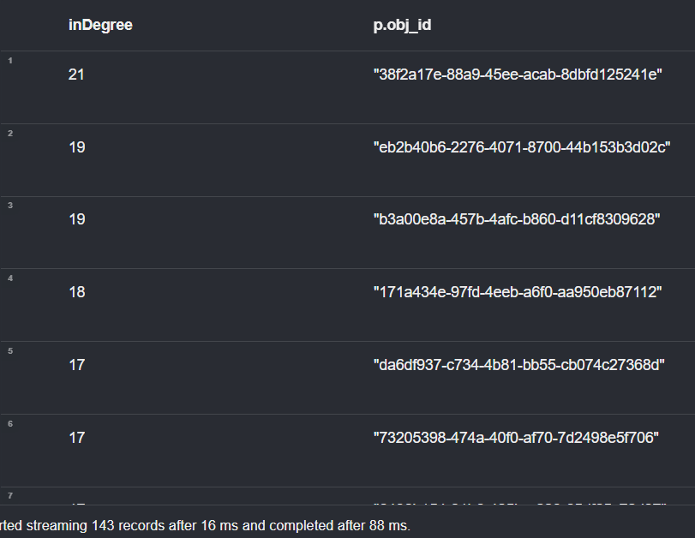
MATCH (p:Account)<-[:TO]-(t:Transfer)
WHERE p.obj_id = "38f2a17e-88a9-45ee-acab-8dbfd125241e"
WITH min(t.timestamp) as minDate, max(t.timestamp) as maxDate
WITH *, (maxDate.epochMillis-minDate.epochMillis)/1000/60/60 as
hoursTimeDelta
RETURN minDate, maxDate, hoursTimeDelta

MATCH (p:Account)
RETURN apoc.node.degree(p,"<TO") AS inDegree, p
ORDER BY inDegree DESC
LIMIT 1;

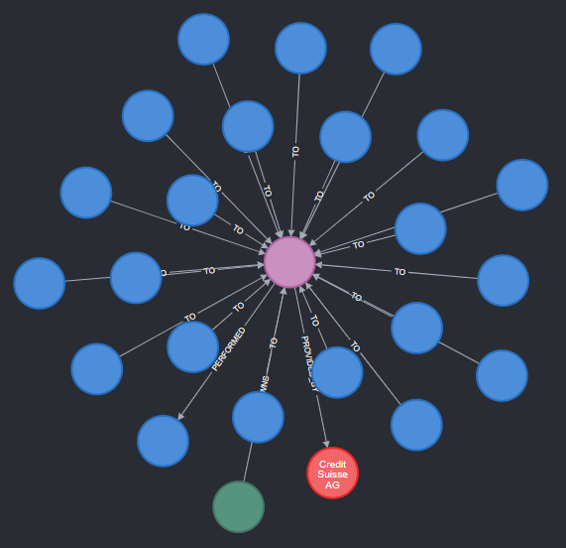
MATCH p=(s:ShellCompany {obj_id:"9e5ae7d7-2482-40be-9e05-4cd55c782060"})-[:OWNS]-(a:Account)-[*]->(a)
RETURN nodes(p)

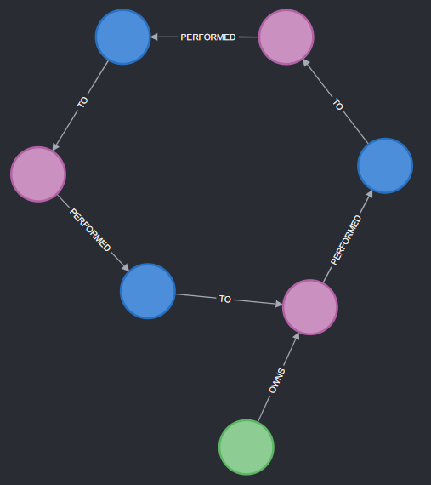
WITH ["4cf2176b-d5ee-4409-a30c-3c9ca1639f61", "ebb647bf-45f2-4246-868d-4ed9d2a30449", "
9e5ae7d7-2482-40be-9e05-4cd55c782060"] as shellCompaniesIds
MATCH p=(s1:ShellCompany)-[*..1]-()-[*..1]-(s2:ShellCompany)
WHERE s1.obj_id IN shellCompaniesIds AND s2.obj_id IN shellCompaniesIds AND
s1.obj_id <> s2.obj_id
RETURN p
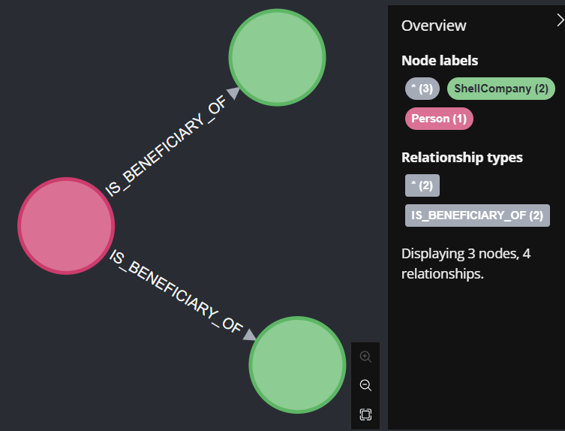
MATCH path=(p:Person)-[*]->()-[:OWNS]->(a:Asset)
WHERE p.obj_id = "580fc4ad-8b88-4f4b-9ef1-19ea974eafa3" AND
toFloat(a.value_in_gbp) > 10000
RETURN path

